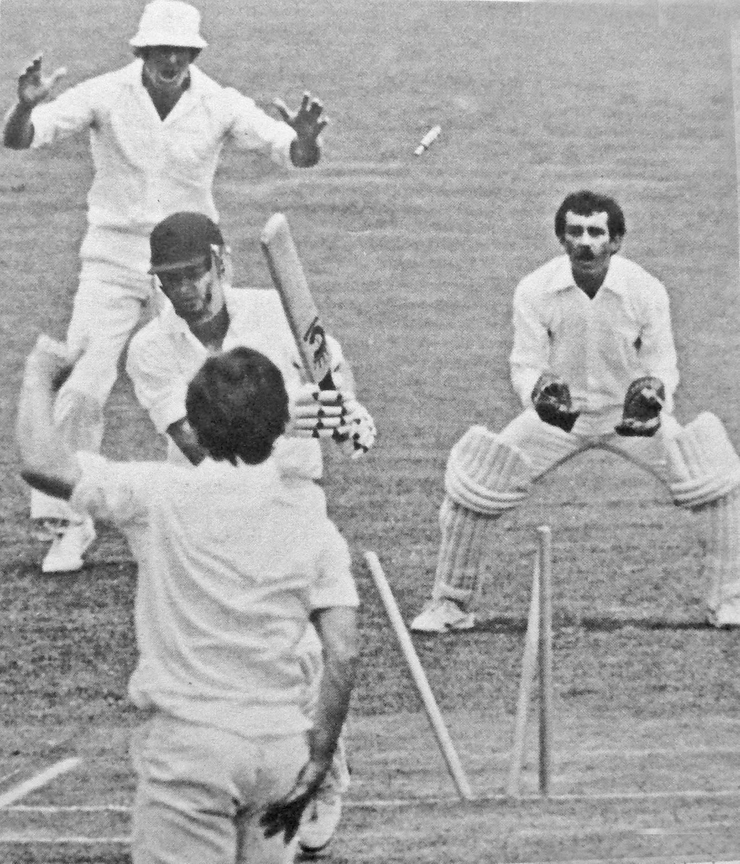

**Glenn Turner bowled by Ian Wilson. Brian Ritchie keeper**

**14 January 1980 Lancaster Park**

**Canterbury 303/5 declared and 253/9 declared. Otago 266 and 294/8. Match drawn**